UML Checking

Checking Implementation of UML Sequence Diagrams

This is a tool that checks if a Java program correctly implements a set of UML 2.x sequence diagrams. To use the tool, you need to prepare a set of UML sequence diagrams drawn by Altova UModel and exported to XMI format and the Java program that implements the sequence diagrams. Then follow the below steps.

Import our project to Eclipse.
For example: We have a xmi file named widthraw.xmi placed at subfoler xmi, and package withdraw in subfolder src/test as below figure:
jpf-uml
|--xmi
|--withdraw.xmi
|--src
|--test
|--withdraw
|--ATM.java
|--User.java
|--Account.java

Annotate the methods that implements sequence diagrams using our annotation. A method can has several @UmlSpec() annotations.
@UmlSpec(sequenceDiagram = { "path to XMI file" }) //annotation

For example: In ATM.java we have:
@UmlSpec(sequenceDiagram = { ".\\xmi\\withdraw.xmi" }) //annotation
public void withdrawMoney(int amount) //method under test

Run configuration
- From Eclipse menu, choose Run -> Run Configurations... then choose a new Java Application. Then in the Main tab: set Main Class to: RunProtocolChecking
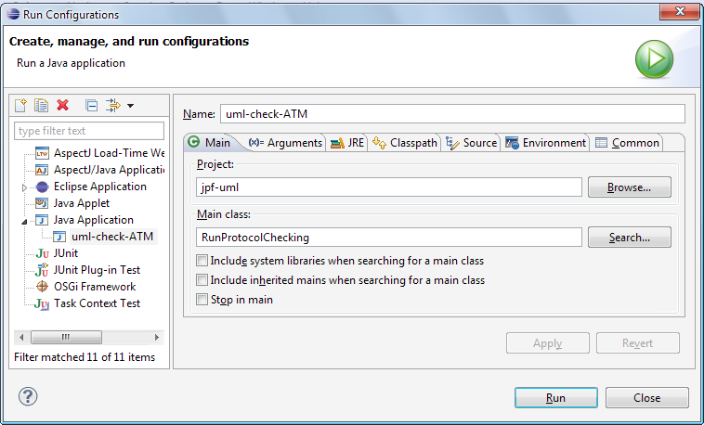

- In Arguments tab: fill your class name that contains the main method. For the above example, it is: withdraw.ATM
*Note: to see verbose results, we add –v argument: withdraw.ATM –v
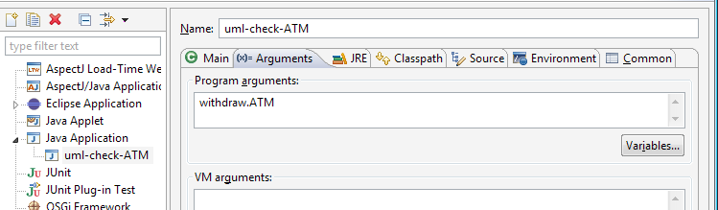

Sample output explained

First example: test connection
Location: src/test/connect
Driver class: TestCallMonitor

---------------------DFA of sequence diagram .\xmi\connect.xmi -------------------------------

[7] --> object1.Connection.destroy --> [8]
[6] --> object1.Connection.disconnect --> [7]
[5] --> object1.CellularRadio.end --> [6]
[4] --> object1.Connection.transfer --> [5]
[3] --> object1.CellularRadio.transfer --> [4]
[2] --> object1.Connection.connect --> [3]
[1] --> object1.Connection.<init> --> [2]
[0] --> object1.CellularRadio.connect --> [1]
Fist state: [0]
Final state : [8]
Number of transition 8
Number of states 9
---------------------***-------------------------------

Above are the deterministic finite automata (DFA) that generated from the sequence diagram

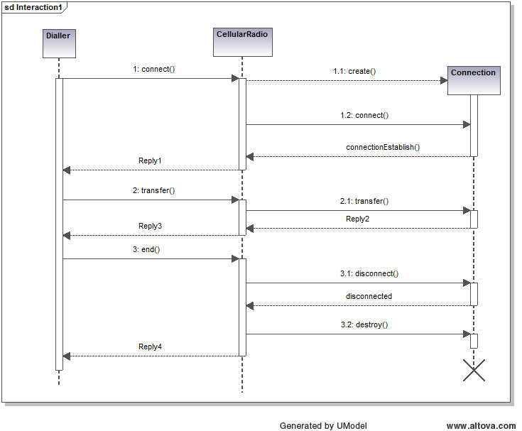
====================================================== method under test: connect.TestCallMonitor.test1

----- Error protocol test cases -----

connect.TestCallMonitor.test1(1000000,1,-1000000)
Error method: "CellularRadio.end" at (connect\Dialler.java:14)
Expected method: "object1.CellularRadio.transfer"

connect.TestCallMonitor.test1(-1000000,-1000000,-1000000)
Not yet finished the sequence diagram
The last method detected in the program is: "Connection.transfer" at (connect\CellularRadio.java:13)

We reported here all test cases that cause the SUT violate the sequence diagram. Each test case is wrapped in the parentheses.

In the first error, the test case is (1000000,1,-1000000), the SUT turn into the path k > 0. In this path, we forgot to implement the message Dialler.transfer(). In runtime, we see that the method CellularRadio.end() is invoked instead of Dialler.transfer(), so we report an error here.

In the second error,the test case is (-1000000,-1000000,-1000000), the SUT turn into the path k < 0. In this path, we forgot to implement the message Dialler.end(). In runtime, we see nothing violated here, but the state machine is not in the last state, so we report a “Not yet finished” error.

----- Valid protocol test cases -----

connect.TestCallMonitor.test1(1000000,0,-1000000)

----------Coverage Published--------

All message in the sequence diagram have been implemented!

------------------------------------

All messages in the SD has been implemented in the SUT and they has been visited at least once time in runtime.

Second example: withdraw money
Location: src/test/withdraw
Driver class: ATM

---------------------DFA of sequence diagram .\xmi\withdraw.xmi -----------

[4] --> object1.User.withdrawMoney --> [1]
[3] --> object1.User.log --> [4]
[2] --> object1.Account.withdrawMoney --> [3]
[2] --> object1.User.log --> [4]
[1] --> object1.Account.getBalance --> [2]
[0] --> object1.User.withdrawMoney --> [1]
Fist state: [0]
Final state : [0]
Final state : [4]
Number of transition 6
Number of states 5
---------------------***-------------------------------

Above are the deterministic finite automata (DFA) that generated from the sequence diagram
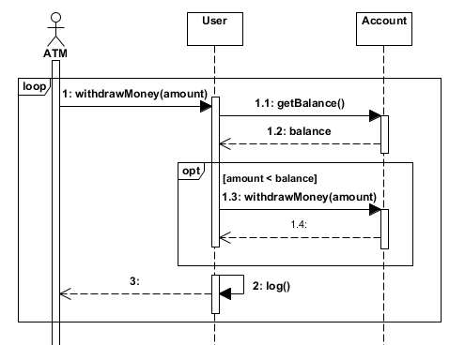

----- Valid protocol test cases -----

withdraw.ATM.withdrawMoney(0)
withdraw.ATM.withdrawMoney(-1000000)
withdraw.ATM.withdrawMoney(1000)

We reported here all valid test cases that do not lead the SUT violate the sequence diagram. Each test case is wrapped in the parentheses.

----------Coverage Published--------

The messages below have never been implemented or are not reachable

object1.User.withdrawMoney

------------------------------------
Above is the transition in the SD that has never been visited in the SUT. This means that we forgot to implement this message (or combined fragment) in the SUT or it is not reachable in runtime.

In this case, the loop fragment in the SD implies that the use can withdraw many times. In the SUT, we’ve just withdraw only one times. To remove this “Coverage” message, we can modify our method under test as below:
@UmlSpec(sequenceDiagram = { ".\\xmi\\withdraw.xmi" }) //annotation
public void withdrawMoney(int amount){ //method under test
if (amount >= 0){
String log = user.withdrawMoney(amount);
System.out.println(log);
}
String log2 = user.withdrawMoney(amount);
}

